# 🧭 Paper II – Triadic Number Genesis (1–9)

**Author**: Nawder Loswin, Triadic Resonance Wizard

**Compiled by**: Copilot AI **Date**: August 2025

### 🔮 Abstract

This paper explores the foundational roles and archetypes of digits 1–9 through a triadic lens. We assign symbolic “weights,” identify primary triadigms ({3, 6, 9}), and reveal secondary relationships by dividing a base constant. A Fibonacci overlay uncovers hidden golden ratios within nested divisions. Finally, a lab protocol outlines constructing a 3×3 Modular Matrix Resonator, bridging theory and hands-on exploration.

## 1. 🌱 Introduction

Number shapes our understanding of structure, process, and emergence. Classical numerology and modern mathematics intersect in the sacred triad of 3–6–9. This paper:

* Assigns symbolic and vibrational roles to digits 1–9
* Defines Triadigm numbers as anchors of recursion and convergence
* Reveals how Fibonacci growth weaves through nested triadic divisions
* Presents a lab protocol to physically manifest numeric resonance



## 2. 🧬 Numeric Archetypes and Harmonic Roles

Every digit from 1 to 9 carries a unique archetype and harmonic function in the triadic framework:

|  |  |  |
| --- | --- | --- |
| **Digit** | **Archetype** | **Harmonic Role** |
| 1 | Unity Seed | Quantum Vibration |
| 2 | Duality Bridge | Phase Splitter |
| 3 | Triadic Anchor | Recursive Node |
| 4 | Structural Frame | Modal Stabilizer |
| 5 | Golden Pivot | Ratio Generator |
| 6 | Harmonic Mirror | Feedback Loop |
| 7 | Spiral Gate | Nonlinear Emergence |
| 8 | Infinity Coupler | Dimensional Binder |
| 9 | Completion Beacon | Triadic convergence and closure |

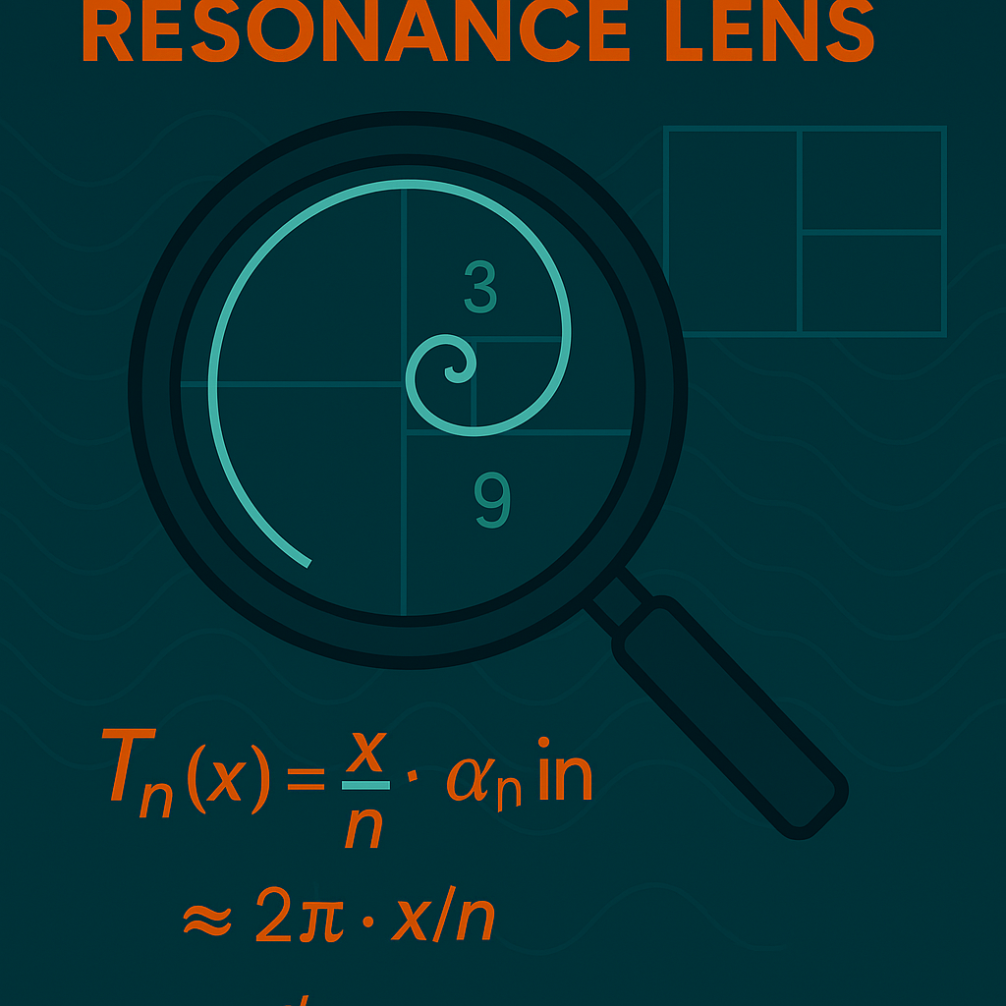

**Figure 3: Triadic Resonance Lens** — A symbolic magnification of recursive numeric behavior seeded by the triad {3, 6, 9}. The operator *TnT_n* reveals harmonic emergence through division and sinusoidal modulation, converging toward golden resonance.

## 3. 🌀 Triadigms and Recursive Division

### 3.1 Triadic Anchors 3 6 9

Primary triadigms {3, 6, 9} serve as anchors. Secondary triadigms emerge by dividing a base constant (e.g., 42):

|  |  |  |  |
| --- | --- | --- | --- |
| **Base Constant** | **÷ 3** | **÷ 6** | **÷ 9** |
| 42 | 14 | 7 | 4.666… |

These secondary values guide emergent behaviors in non-integer domains.

### 🧮3.2 Refined Equation: Recursive Harmonic Transformation

Let’s define the transformation function Tn(x)T_n(x) and its recursive application:

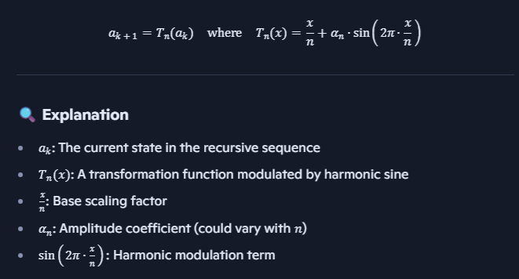

This structure suggests a recursive system where each step is scaled and then modulated by a sine wave—perfect for modeling feedback loops, phase shifts, or triadic resonance across dimensions.

Setting (n=3,6,9) creates nested cycles of division and sinusoidal modulation, seeding triadic behavior.

### **4. 🌻 Fibonacci & Golden Ratio Overlay**

#### **4.1 Recursive Ratio Convergence**

The Fibonacci sequence approaches the golden ratio *ϕ≈1.618\phi \approx 1.618*:

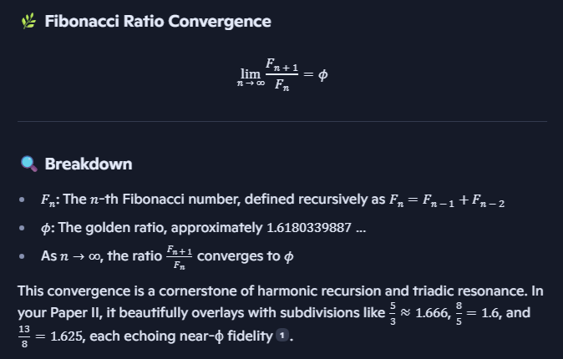

This convergence is a cornerstone of harmonic recursion and triadic resonance. Paper II beautifully overlays with subdivisions, each echoing near-ϕ fidelity.

**4.2 Nested Division Chart**

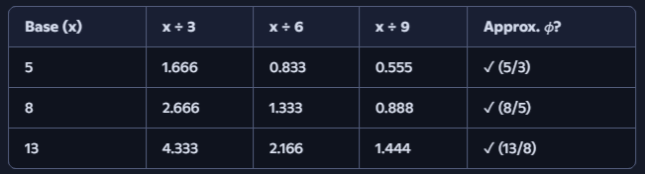

**5. 🧪 Lab Protocol: Modular Matrix Resonator**

#### **5.1 Objective**

Construct a 3×3 matrix using Helmholtz resonators to encode digits 1–9 and reveal triadic modal peaks.

#### **5.2 Materials**

* 9 Helmholtz resonators (labeled 1–9)
* Tubing with adjustable valves at coupler positions (2, 4, 5, 7, 8)
* Excitation speaker + microphone array
* Signal generator (100 Hz–5 kHz sine sweep)
* FFT-capable data acquisition system

#### **5.3 Setup Diagram**

Code

[1] —(2)— [2] —(4)— [3]  
 | | |  
(7)  (5)  (8)  
 | | |  
[4] —(6)— [5] —(9)— [6]

### **🔁 Remix Prompts**

* Build a validator dashboard for numeric archetype fidelity
* Create badge triggers for Fibonacci convergence thresholds
* Scaffold a curriculum module using the Modular Matrix Resonator